Y&H Transition Education and Training Strategy
Young people face many challenges when preparing for adult life and for children and young people with complex physical health needs, there are variety additional hurdles for them to overcome.

In many cases, the health needs of these children and young people will have been supported and met by the same people who have cared for them for as long as they can remember, building relationships, trust and an understanding of how things work.

However young people have to move on from children’s to adult services and an adult environment where they may need to consult with several different health teams, therapy teams, and adult social care services.

It is therefore essential that children and young people are fully supported through this process and confident to move on, take ownership of their health and navigate the complexities of adult services

One of the biggest barriers to effective transition is lack of confidence and training for staff in communication and working with children and young people, resulting in poor relationships with young people in adult services

It has been noted that a ‘key element in designing and accommodating transition services for young people was a 'cultural shift in NHS staffs attitudes and training' as well as changes to healthcare systems"

A transition processes should be embedded in all organisations and is the responsibility of all staff, not just the ones in children’s services.

In 2013 the Royal College of Nursing published their report ‘Lost in Transition’ (http://www.rcn.org.uk/data/assets/pdffile/0010/157879/003227WEB.pdf) detailing principles of good practice for transition and engaging with CYP. The report recommends that; all staff working with young people and young adults must receive specific training to facilitate the transition between services. Young people need support and education to prepare them to develop resilience and cope with transition
It is therefore essential that all staff receive appropriate training around working with children and young people, the issues of transition and how their organisation supports this process.

Training Structure

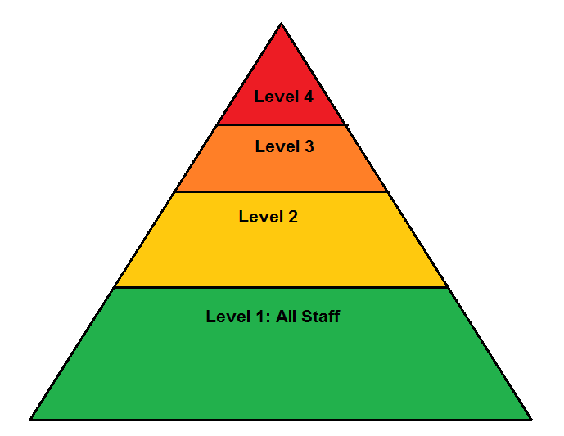

The structure above shows 4 levels of Transition training depending on the level of involvement staff have in the transition of young people into adult services.

Level 1: All Staff

It is recommended that all staff, including adult service staff, should have a basic level of training around children and adolescents. This training can be as simple as communication with YP and families. It is hoped that this would become part of the mandatory training staff need to complete on an annual basis or at least part of their priority training.

Level 2: Staff in a service where there are children transitioning but not directly involved in providing their care

This level of training gives the background to transition and how this affects the young person and their parent / carer. It means that any member of staff working in the areas where a child is transitioning will be aware of the process and be able to communicate and work with the individual appropriately. This training should be provided to both the children and adult services.

Level 3: Staff directly involved in providing care to a child or young person who is transitioning to an adult service

Staff directly involved in a transitioning persons care should have all information on the transition process and effects this can have on the individual. They need to be fully informed of the transition stage and the steps involved in good transition. This training should be provided to both the child and adult services providing the care.

Level 4: Transition Lead

All providers should have individuals that are responsible for leading transition in the organisation. These individuals will have direct responsibility to ensure all children and young people requiring transition to adult services are identified and are cared for according to the organisations transition pathways and protocols.

From the Pond into the Sea CQC
From the Pond into the Sea CQC
McDonagh et al 2004,2006 cited in building a caring future.
Viner.R.M; Transition of care from Paediatric to adult services: one part of improved health services for adolescents. Arch Disabil childhood 2008; 93 160-3 cited in Price.c, Clinpsy. D, Corbett.s, Davey -Pearce.G, Northumbria Healthcare NHS Foundation Trust, North Tyneside General Hospital; international Journal of child and Adolescent Health volume3, number4- special issue pp 489-498 2010 Nova Science Publishers, inc

